BANK LOAN REPORT QUERY DOCUMENT
- BANK LOAN REPORT | SUMMARY
KPI’s:
KPI 1 Total Loan Applications
Select count(id) as total_loan_applications
from bank_loan_data

MoM Loan Applications
Select count(id) as total_loan_app_by_latestmonth
from bank_loan_data
where month(issue_Date) = (select month(max(issue_date)) from bank_loan_data)
Select count(id) as total_loan_app_by_prevmonth
from bank_loan_data
where month(issue_Date) = (select month(max(issue_date))-1 from bank_loan_data)
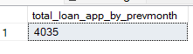
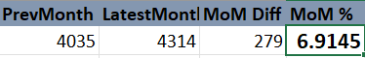
Advance Method :
Declare @CurrentMonth decimal(10,2);
Select @CurrentMonth = count(id)
from bank_loan_data
where month(issue_Date) = (select month(max(issue_date)) from bank_loan_data);

Declare @PrevMonth decimal(10,2);
Select @PrevMonth = count(id)
from bank_loan_data
where month(issue_Date) = (select month(max(issue_date))-1 from bank_loan_data);

Declare @MoM_LoanApp decimal(10,2);
Set @MoM_LoanApp = ((@CurrentMonth -@PrevMonth) / @PrevMonth) * 100

Select concat(@MoM_LoanApp, ' %') as MoM_LoanAppPercent;
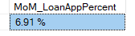

KPI 2 Total Fund MoM
Declare @totalfund decimal(15,2)
Select @totalfund =sum(loan_amount) from bank_loan_data

Declare @LatestMonthFundedAmnt decimal(10,2)
Select @LatestMonthFundedAmnt =sum(loan_amount) from bank_loan_data
where month(issue_date)= (select month(max(issue_date)) from bank_loan_data)

Declare @PrevMonthFundedAmnt decimal(10,2)
Select @PrevMonthFundedAmnt =sum(loan_amount) from bank_loan_data
where month(issue_date)= (select month(max(issue_date))-1 from bank_loan_data)

Declare @MoMFundedAmountPerc decimal(10,2)
Set @MoMFundedAmountPerc = ((@LatestMonthFundedAmnt -@PrevMonthFundedAmnt)/@PrevMonthFundedAmnt) * 100

Select
@totalfund as totalfund,
@LatestMonthFundedAmnt as latestmonthfund,
@PrevMonthFundedAmnt as prevmonthfund,
concat(@MoMFundedAmountPerc,' %') as MoMFundedAmountPercent

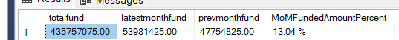

KPI 3 Total Received Amount (MoM)
Declare @totReceivedAmnt decimal(15,2)
Select @totReceivedAmnt =sum(total_payment) from bank_loan_data

Declare @LatestMonthReceivedAmnt decimal(10,2)
Select @LatestMonthReceivedAmnt =sum(total_payment) from bank_loan_data
where month(issue_date)= (select month(max(issue_date)) from bank_loan_data)

Declare @PrevMonthReceivedAmnt decimal(10,2)
Select @PrevMonthReceivedAmnt =sum(total_payment) from bank_loan_data
where month(issue_date)= (select month(max(issue_date))-1 from bank_loan_data)

Declare @MoMReceivedAmountPerc decimal(10,2)
Set @MoMReceivedAmountPerc = ((@LatestMonthReceivedAmnt -@PrevMonthReceivedAmnt)/@PrevMonthReceivedAmnt) * 100

Select
@totReceivedAmnt as TotalReceivedAmount,
@LatestMonthReceivedAmnt as LatestmonthReceivedAmount,
@PrevMonthReceivedAmnt as PrevmonthReceivedAmount,
concat(@MoMReceivedAmountPerc,' %') as MoMReceivedAmountPercent

KPI 4 Average Interest rate(MoM)
Declare @AvgIntrate decimal(10,2)
Select @AvgIntrate=avg(int_rate)*100 from bank_loan_data

Declare @AvgIntrateCurrMnth decimal(10,2)
Select @AvgIntrateCurrMnth=avg(int_rate)*100 from bank_loan_data
where month(issue_date)= (select month(max(issue_date)) from bank_loan_data)

Declare @AvgIntratePrevMnth decimal(10,2)
Select @AvgIntratePrevMnth=avg(int_rate)*100 from bank_loan_data
where month(issue_date)= (select month(max(issue_date))-1 from bank_loan_data)

Declare @AvgIntrateMoM decimal(10,2)
Set @AvgIntrateMoM = ((@AvgIntrateCurrMnth-@AvgIntratePrevMnth)/@AvgIntratePrevMnth)*100

Select
@AvgIntrate as AvgInterestRate,
@AvgIntrateCurrMnth as AvgInterestRateCurrMonth,
@AvgIntratePrevMnth as AvgInterestRateLatMonth,
concat(@AvgIntrateMoM,' %') as MoMAvgInterestRate

KPI 5 Average Debt To Income (MoM)
Declare @AvgDTI decimal(10,2)
Select @AvgDTI=avg(dti)*100 from bank_loan_data

Declare @AvgDTICurrMnth decimal(10,2)
Select @AvgDTICurrMnth=avg(dti)*100 from bank_loan_data
where month(issue_date)= (select month(max(issue_date)) from bank_loan_data)

Declare @AvgDTIPrevMnth decimal(10,2)
Select @AvgDTIPrevMnth=avg(dti)*100 from bank_loan_data
where month(issue_date)= (select month(max(issue_date))-1 from bank_loan_data)

Declare @AvgDTIMoM decimal(10,2)
Set @AvgDTIMoM = ((@AvgDTICurrMnth-@AvgDTIPrevMnth)/@AvgDTIPrevMnth)*100

Select
@AvgDTI as AvgDebtToIncome,
@AvgDTICurrMnth as CurrMonthAvgDebtToIncome,
@AvgDTIPrevMnth as LatMonthAvgDebtToIncome,
concat(@AvgDTIMoM,' %') as MoMAvgDebtToIncome

KPI 6 Good Loan KPI’s

Declare @TotalLoanApp decimal(10)
Select @TotalLoanApp= count(id) from bank_Loan_data

Declare @GoodLoanApp decimal(10)
SELECT @GoodLoanApp = COUNT(*) FROM bank_Loan_data
WHERE loan_status IN ('Fully Paid', 'Current');

Declare @GoodLoanAppPerc decimal(5,2)
SET @GoodLoanAppPerc= (@GoodLoanApp*100) / @TotalLoanApp

Declare @GoodLoanFundedAmount decimal (15,2)
Select @GoodLoanFundedAmount=sum(loan_amount) from bank_Loan_data
WHERE loan_status IN ('Fully Paid', 'Current');

Declare @GoodLoanReceivedAmount decimal(15,2)
Select @GoodLoanReceivedAmount=sum(total_payment) from bank_Loan_data
WHERE loan_status IN ('Fully Paid', 'Current');

Select @TotalLoanApp as TotalLoanApplications,
@GoodLoanApp as GoodLoanApplications,
concat(@GoodLoanAppPerc,' %') as GoodLoanApplicationPercentage,
@GoodLoanFundedAmount as GoodLoanFundedAmount,
@GoodLoanReceivedAmount as GoodLoanReceivedAmount

KPI 7 BAD Loan KPI’s
Declare @TotalLoanApp decimal(10)
Select @TotalLoanApp= count(id) from bank_Loan_data

Declare @BadLoanApp decimal(10)
SELECT @BadLoanApp = COUNT(*) FROM bank_Loan_data
WHERE loan_status ='Charged Off';

Declare @BadLoanAppPerc decimal(5,2)
SET @BadLoanAppPerc= (@BadLoanApp*100) / @TotalLoanApp

Declare @BadLoanFundedAmount decimal (15,2)
Select @BadLoanFundedAmount=sum(loan_amount) from bank_Loan_data
WHERE loan_status ='Charged Off';

Declare @BadLoanReceivedAmount decimal(15,2)
Select @BadLoanReceivedAmount=sum(total_payment) from bank_Loan_data
WHERE loan_status ='Charged Off';

Select @TotalLoanApp as TotalLoanApplications,
@BadLoanApp as BadLoanApplications,
concat(@BadLoanAppPerc,' %') as BadLoanApplicationPercentage,
@BadLoanFundedAmount as BadLoanFundedAmount,
@BadLoanReceivedAmount as BadLoanReceivedAmount

KPI 8 LOAN STATUS
SELECT
loan_status,
COUNT(id) AS LoanCount,
SUM(total_payment) AS Total_Amount_Received,
SUM(loan_amount) AS Total_Funded_Amount,
AVG(int_rate * 100) AS Interest_Rate,
AVG(dti * 100) AS DTI
FROM
bank_loan_data
GROUP BY
loan_status
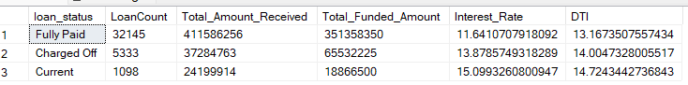

SELECT
loan_status,
SUM(total_payment) AS MTD_Total_Amount_Received,
SUM(loan_amount) AS MTD_Total_Funded_Amount
FROM bank_loan_data
WHERE MONTH(issue_date) =(select month(max(issue_date)) from bank_loan_data)
GROUP BY loan_status
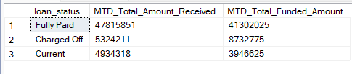

BY MONTH
SELECT
MONTH(issue_date) AS Month_Munber,
DATENAME(MONTH, issue_date) AS Month_name,
COUNT(id) AS Total_Loan_Applications,
SUM(loan_amount) AS Total_Funded_Amount,
SUM(total_payment) AS Total_Amount_Received
FROM bank_loan_data
GROUP BY MONTH(issue_date), DATENAME(MONTH, issue_date)
ORDER BY MONTH(issue_date)

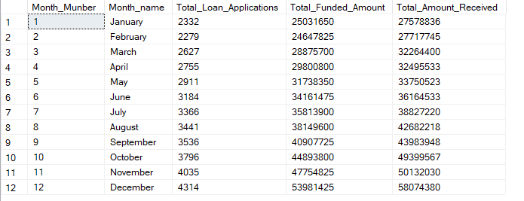

BY STATE
SELECT
address_state AS State,
COUNT(id) AS Total_Loan_Applications,
SUM(loan_amount) AS Total_Funded_Amount,
SUM(total_payment) AS Total_Amount_Received
FROM bank_loan_data
GROUP BY address_state
ORDER BY count(id) desc
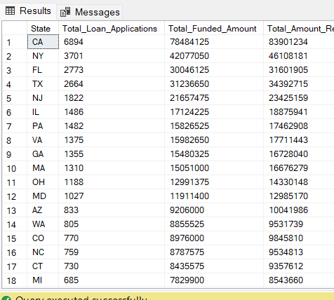

BY TERM
SELECT
term AS Term,
COUNT(id) AS Total_Loan_Applications,
SUM(loan_amount) AS Total_Funded_Amount,
SUM(total_payment) AS Total_Amount_Received
FROM bank_loan_data
GROUP BY term
ORDER BY term
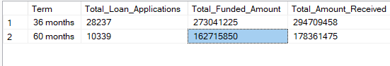

BY EMPLOYEE LENGTH
SELECT
emp_length AS Employee_Length,
COUNT(id) AS Total_Loan_Applications,
SUM(loan_amount) AS Total_Funded_Amount,
SUM(total_payment) AS Total_Amount_Received
FROM bank_loan_data
GROUP BY emp_length
ORDER BY
CASE
WHEN emp_length = '< 1 year' THEN 0
WHEN emp_length = '1 year' THEN 1
WHEN emp_length = '2 years' THEN 2
WHEN emp_length = '3 years' THEN 3
WHEN emp_length = '4 years' THEN 4
WHEN emp_length = '5 years' THEN 5
WHEN emp_length = '6 years' THEN 6
WHEN emp_length = '7 years' THEN 7
WHEN emp_length = '8 years' THEN 8
WHEN emp_length = '9 years' THEN 9
WHEN emp_length = '10+ years' THEN 10
ELSE 11
END;
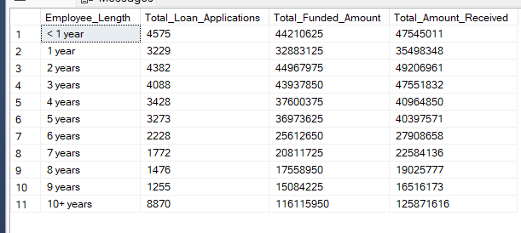

BY PURPOSE
SELECT
purpose AS PURPOSE,
COUNT(id) AS Total_Loan_Applications,
SUM(loan_amount) AS Total_Funded_Amount,
SUM(total_payment) AS Total_Amount_Received
FROM bank_loan_data
GROUP BY purpose
ORDER BY purpose
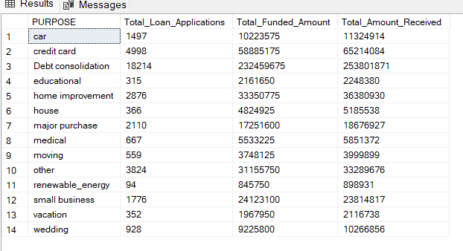

BY HOME OWNERSHIP
SELECT
home_ownership AS Home_Ownership,
COUNT(id) AS Total_Loan_Applications,
SUM(loan_amount) AS Total_Funded_Amount,
SUM(total_payment) AS Total_Amount_Received
FROM bank_loan_data
GROUP BY home_ownership
ORDER BY home_ownership
